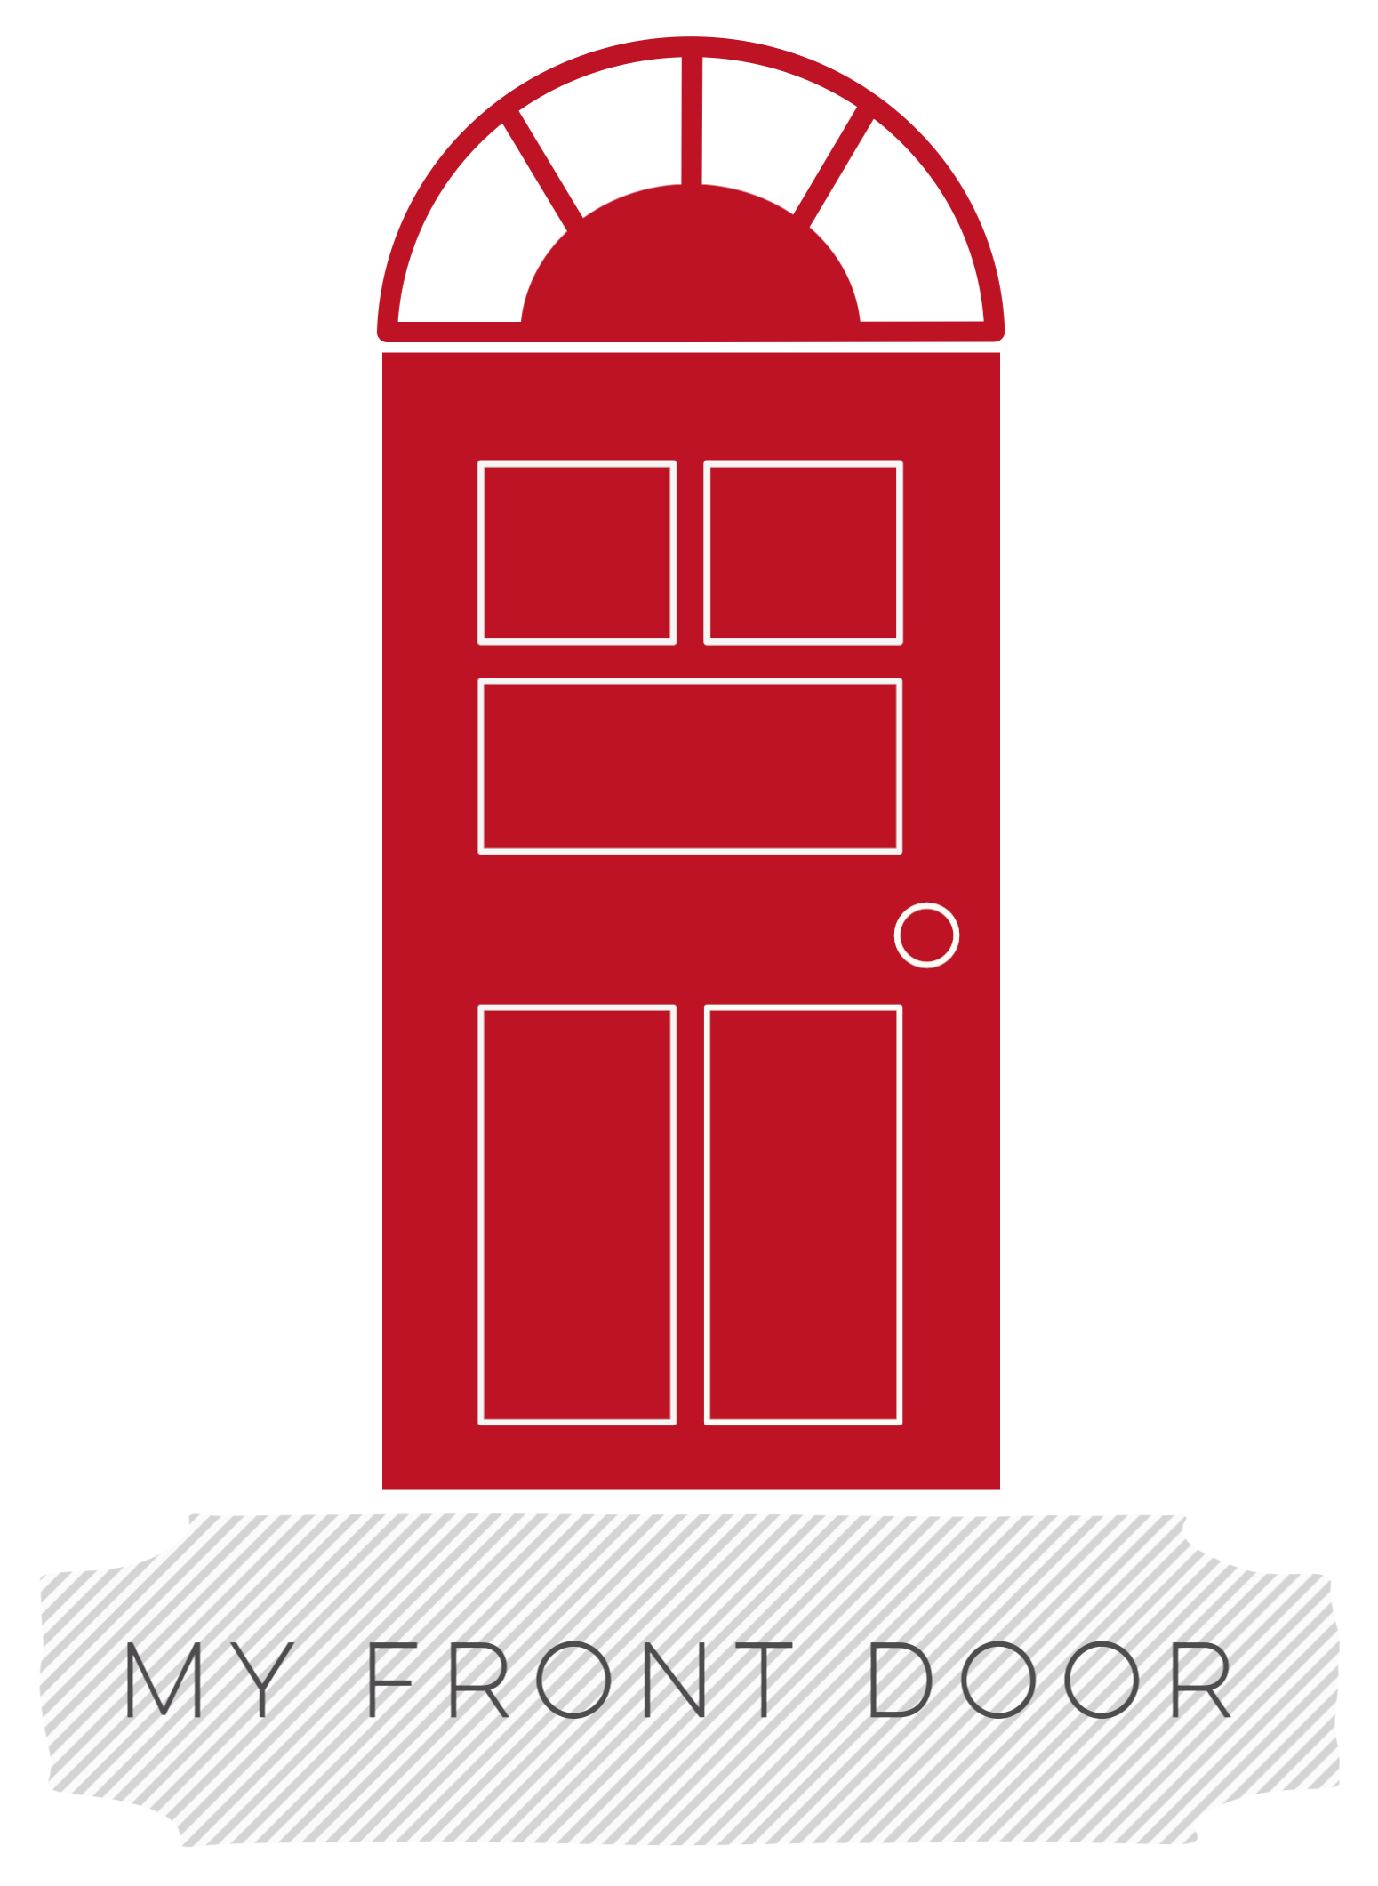
Donor Privacy Policy Template
Below is a sample privacy notice that you may want to use as a guide for your privacy notice. Note that there is a place for your company name or URL in the first paragraph, and a place for your phone number and email address in the last paragraph. Please make sure to personalize these. DO NOT simply cut and paste this policy as is.
Privacy Notice
This privacy notice discloses the privacy practices for My Front Door (www.myfrontdoor.org). This privacy notice applies solely to information collected by this website. It will notify you of the following:
- What personally identifiable information is collected from you through the website, how it is used, and with whom it may be shared.
- What choices are available to you regarding the use of your data.
- The security procedures in place to protect against the misuse of your information.
- How you can correct any inaccuracies in the information.
- How policy changes will be communicated.
Information Collection, Use, and Sharing
We are the sole owners of the information collected on this site. We only have access to/collect information that you voluntarily give us via email or through other direct means of contact from you. We will not sell or share this information to anyone. General information collected can include name, address, phone number, email or web address, credit card information etc.

We will use your information to respond to you, regarding the reason you contacted us. We will not share your information with any third party outside of our organization, other than as necessary to fulfill your request, e.g. to ship an order.

We use "cookies" on this site. A cookie is a piece of data stored on a site visitor's hard drive to help improve your access to our site and identify repeat visitors to our site. For instance, when we use a cookie to identify you, you may not have to log in with a password more than once, thereby saving time while on our site. Cookies can also enable us to target the interests of our users to enhance the experience on our site. The usage of a cookie is in no way linked to any personally identifiable information on our site.

Some of our business partners may use cookies on our site (for example, advertisers). However, we have no access to or control over these cookies.

This website contains links to other sites. Please be aware that we are not responsible for the content or privacy practices of such other sites.

Unless you ask us not to, we may contact you via email in the future to tell you about our class starts, and program events, and to share our newsletter.

Your Access to and Control Over Information
You may opt out of any future contacts from us at any time. You can do the following at any time by contacting us via the email address or phone number given on our website:
- See what data we have about you, if any.
- Change/correct any data we have about you.
- Have us delete any data we have about you.
- Express any concern you have about our use of your data.
Security
We take precautions to protect your information. When you submit sensitive information via the website, your information is protected both online and offline.

Wherever we collect sensitive information (such as credit card data), that information is encrypted and transmitted to us in a secure way. You can verify this by looking for a closed lock icon at the bottom of your web browser or looking for "https" at the beginning of the address of the web page.

While we use encryption to protect sensitive information transmitted online, your information is also protected offline. Only employees who need the information to perform a specific job (for example, billing and accounting) are granted access to personally identifiable information. We are a cloud-based and secure environment.

Changes to this Policy
Changes may be made to this privacy notice. You can check back on this page at any time to see our current policy.
If you feel that we are not abiding by this privacy policy, you should contact us immediately via telephone at 307-514-5831 or hello@myfrontdoor.org.

